**IST 370**

**Lab Assignment 1 (40 points)**

Spring 2017

Theme: Table Creation Using DDL

|  |
| --- |
| Instructions:   * You should submit a WORD document with necessary screenshots showing your SQL statements and corresponding query results (see the following example). Make sure that the images of your screenshots are of a size big enough to be legible. Those submissions without following the instructions or with illegible images will be returned for resubmission.   Example: |

Problems

According to the given initial ERD shown as below, you are to create four database tables using DDL: customers, orders, order_details, and products.

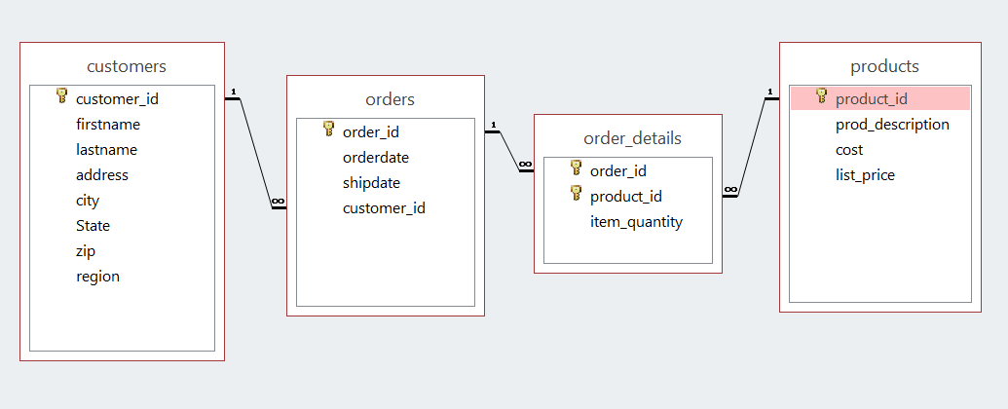

**TIP: The parent table should always be created before the child table is created.**

**1. Creating CUSTOMERS table (10 points)**

CUSTOMERS table serves as a master table for storing basic data related to a customer who has placed an order with JustLee Books. It stores the customer’s name, e-mail address, and mailing address, plus the Customer# of the person who referred that customer to the company. The region data allows JustLee Books to track and analyze sales by geographic service areas.

**TASK 1.1: Column Definition**

Column Properties:

Column Name Data Type Column Size

customer_id CHAR 6

firstname VARCHAR2 30

lastname VARCHAR2 30

address VARCHAR2 50

city VARCHAR2 20

state CHAR 2

zip CHAR 5

region CHAR 2

** You can use the command, DESCRIBE (or DESC), to display the structure of the table you just created.

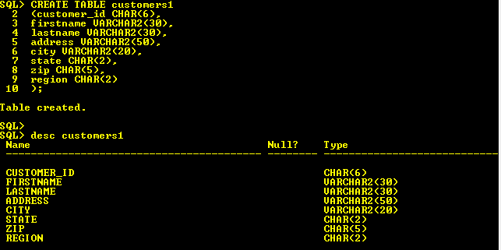

TASK 1.2: Constraint Definition

Define the following constraints to the relevant table(s):

1. Add a constraint to specify *Customer#* as the **primary key** of Customers.
2. Add a constraint that makes lastname and firstname contain **no null values**.
3. Set the **default value** for state to IL.
4. The regions of all the customers are classified into NE (northeast), SE (southeast), SW (southwest), MW (midwest) and W (west), PN (Pacific NW) and PO (Pacific Ocean). Define a constraint is necessary to check every customer should fall into one of 8 regions and nothing else.

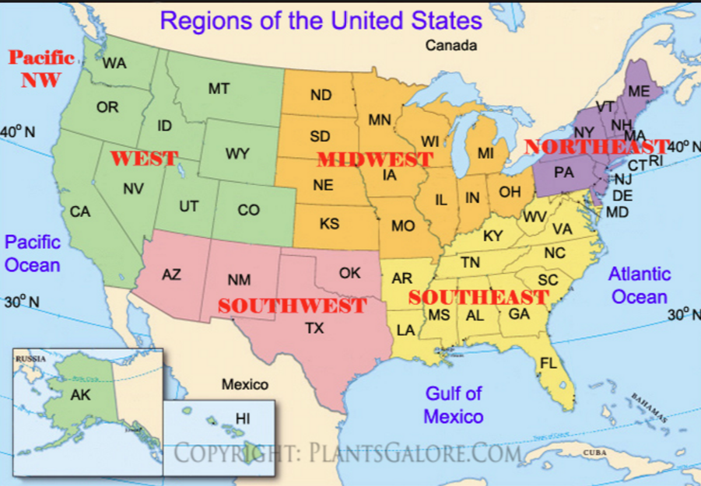

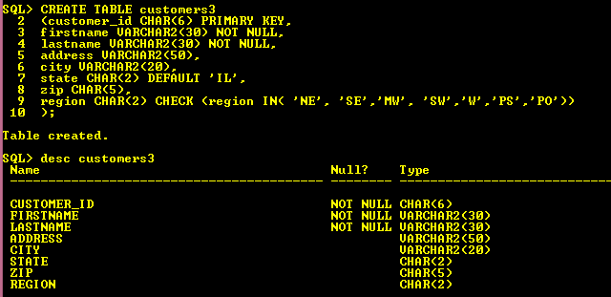

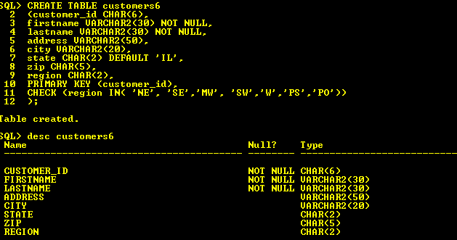

**2. Creating ORDERS table (10 points)**

The ORDERS table identifies which customer placed each order, the date the order was placed, the date it was shipped, and the shipping cost charged. Because the shipping address might be different from a customer’s billing address, the shipping address is also stored in the ORDERS table.

**TASK 2.1: Column Definition**

Column Properties:

Column Name Data Type Column Size

order_id CHAR 3

orderdate DATE

shipdate DATE

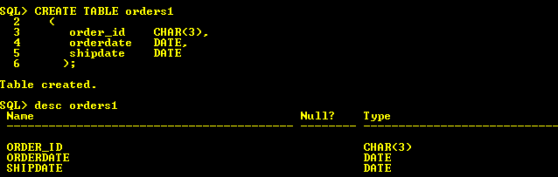

TASK 2.2: Constraint Definition

1. Add a constraint to specify *order_id* as the **primary key** of Orders.
2. Add a constraint to assign a **foreign key** to implement the **1:M relationship** between customers and orders.
3. Set the **default value** for orderdate to the current system time (i.e., **SYSDATE**).
4. Create a constraint to **check** that **the order date always takes place on the same day as the ship date or prior to the ship date.**

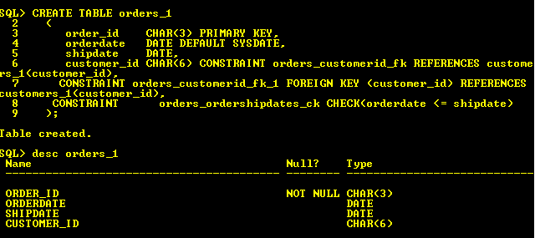

**3. Creating PRODUCTS table (10 points)**

**TASK 3.1: Column Definition**

Column Name Data Type Column Size

product_id CHAR 6

product_description VARCHAR2 50

cost NUMBER (5,2)

list_price NUMBER (5,2)

TASK 3.2: Constraint Definition

1. Add a constraint to assign isbn as the **primary key** of Books.
2. Set the values of product_description to be unique for each product and contain no null values.

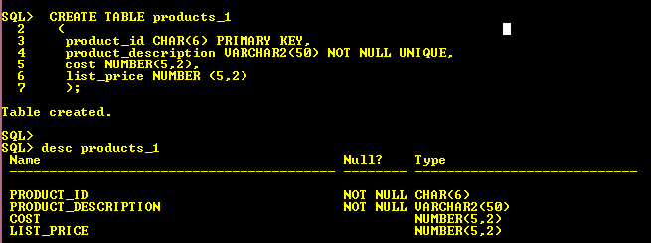

**4. Creating ORDER_DETAILS table (10 points)**

**TASK 4.1: Column Definition**

Column Name Data Type Column Size

order_id CHAR 6

product_id CHAR 6

item_quantity NUMBER 10

TASK 4.2: Constraint Definition

1. Define a **composite primary key**.
2. Define two **foreign keys** to implement the **1:M relationship**.
3. Set the values of item_quanity to be NOT NULL and be greater than 0.

